EVENING MEETING

Monday 16th November 2026 at 6:00pm

One Great George Street, London (Nearest tube: Westminster)

New UK Dams – Update
Portsmouth Water / Anglian Water / Thames Water
SSE / Agilia

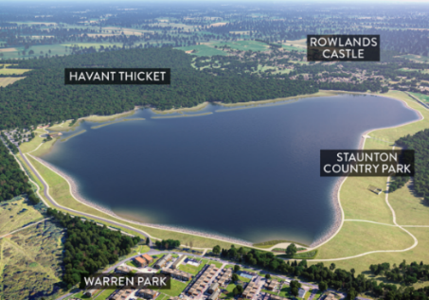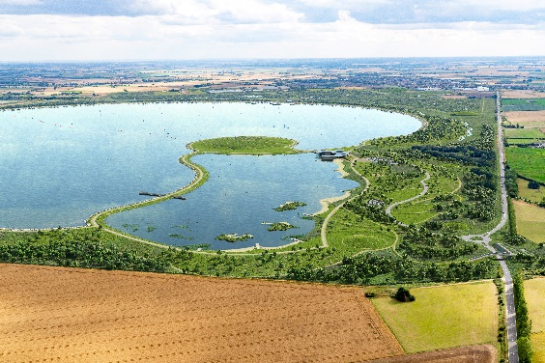
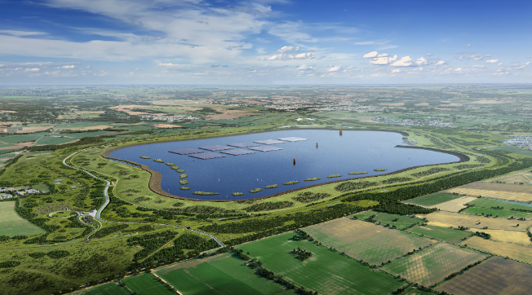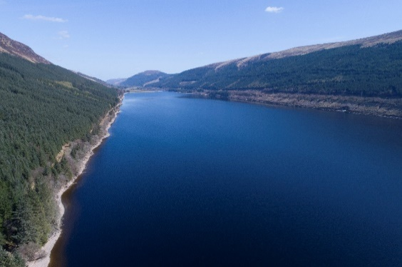

For synopsis and brief presenter biography see overleaf | Admission free | Teas available from 5.30pm

This meeting will be live at the ICE in the Godfrey Mitchell Lecture Theatre and available on the internet. For more details, including enjoying the live stream as part of a group at one of our Regional Hubs around the UK, please visit the meetings page on the BDS website: www.britishdams.org
For more information, please contact the ICE on 020 7665 2147 or email: bds@ice.org.uk
Synopsis
Havant Thicket Reservoir – Portsmouth Water

Havant Thicket Reservoir in Hampshire is England’s first major new reservoir to be constructed in over 30 years. The 160-hectare reservoir will hold 8.7 million m3 of water and is nearing the end of its second year of construction. The design and scope of the project has changed so that the reservoir will have the capacity and flexibility to increase the amount of the water that the reservoir can supply fivefold in the future – from 21 million litres per day, to up to 111 million litres per day during a drought or emergency. The change will also enable the reservoir to supply 20 million litres of water every day during normal operations.

The presentation will describe how strong collaboration between water companies, regulators, engineers, and construction partners have ensured that construction continued at pace, in parallel with the introduction of change.

Fens Reservoir and Lincolnshire Reservoir – Anglian Water

Anglian Water is developing two large new raw water reservoirs for the East of England: the Fens Reservoir near Chatteris in Cambridgeshire (in partnership with Cambridge Water) and the Lincolnshire Reservoir near Sleaford to the south of Lincoln. Each reservoir will cover over 5km2 and hold 55 million m3 of water. The schemes also include significant river abstraction facilities, water transfers via open channels and pipelines, and water treatment plants. The projects are currently progressing through planning development and undertaking site investigation works, with the aim to achieve consent approvals and start construction in the early 2030s. The completed new water supply systems are expected to become operational in the late 2030s and will address the challenges of climate change, environmental restoration and population growth.

White Horse Reservoir – Thames Water

White Horse Reservoir (WHR) is a proposed raw water storage reservoir to the south west of Abingdon, which would supply water to 15 million people in the South East, including customers in the Thames Water, Affinity Water and Southern Water areas. It is a 150 million cubic metre non-impounding reservoir which is linked to upper catchment of the River Thames by a 3.5km tunnel. The nationally significantly infrastructure project is currently in the development phase with the Development Consent Order due to be submitted to the Planning Inspectorate in late 2026 and invitation to tender for the Main Works Contract issued recently. The aim is to have water available for use by 2040 to help protect supplies and manage future water quality issues created by a growing population and changing climate.

Coire Glas Pumped Storage Project

Coire Glas is a proposed hydro pumped storage project in the Scottish Highlands with a total capacity of 1500 MW. The project will be located in the Great Glen and would use Loch Lochy as the lower reservoir with a new upper reservoir built in the Coire Glas creating almost 550 m of head for hydropower generation. Planning approval for the project was granted by Scottish Government in 2020 and SSE Renewables are progressing with design and procurement under a traditional design-bid-build model.

The project would be the first large scale pumped storage project to be developed in the UK since Dinorwig was commissioned in the early 1980s and will play an essential role in decarbonising the UKs electricity supply by integrating more renewable energy.

The presentation will provide an update on the project, including the completed exploratory works and ground investigation, the proposed 115 m high upper dam and the complex underground works.

Matthew Hill will provide an update on the development of the 1500 MW Coire Glas hydro pumped storage project that is progressing through FEED (Front-End-Engineering-Design) phase, with particular emphasis on the upper dam, which will be the tallest dam in the UK once completed.

Reservoir Programme

Up to ten new reservoirs, with an estimated capital value of over £20 billion, are planned in England over the next 25 years to address rising water demand driven by population growth, climate change and the need for greater drought resilience.

The presentation will set out the background to the forecast need for more water and the proposed reservoir programme. Securing additional investment into the sector is essential if the programme is to be delivered at the required scale and pace. The presentation will therefore explore the magnitude of the financing challenge and review the innovative delivery and funding models under consideration, including key aspects such as risk allocation and value for money.

Presenter’s Biographies
 Ruari Maybank | Programme Director – Havant Thicket Reservoir – Portsmouth Water
Ruari has over 25 years of experience in leading and delivering major infrastructure projects and has been a director at Portsmouth Water since 2021. Previous projects include the expansion of London Luton Airport, transport infrastructure for the FIFA World Cup Qatar, utilities infrastructure for the London 2012 Olympic and Paralympic Games, the Millennium Dome, and several Private Finance Initiatives.
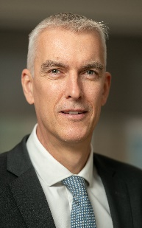 Mark Malcolm | Reservoirs Programme Director – Anglian Water
Mark leads the New Reservoirs Programme for Anglian Water having joined the company in 2020. He brings major project experience having worked for client and Tier 1 contractor organisations, both in development and delivery, including leading design and build programmes within the UK and internationally. He is a chartered Civil Engineer and a Fellow of the Institution of Civil Engineers with a passion for developing teams and project delivery.

Robert Smith | Project Development Manager – Thames Water
Robert is a chartered civil engineer with 20 years’ experience in the industry. He joined Thames Water’s Strategic Resource Options (SROs) team as Project Development Manager for White Horse Reservoir (WHR) in early 2024. He is responsible for the delivery of the Development Consent Order and development of the Main Works Contract.
 Matt Hill | Senior Technical Director at Stantec and All Reservoirs Panel Engineer
Matthew has 30 years’ experience in dam engineering and hydropower projects. Matthew has been responsible for the design of many new dams both in the UK and internationally and has worked on water supply and hydropower projects in more than 15 countries.
Matthew has been involved with the Coire Glas project since 2010, when initial feasibility studies and an initial planning application was submitted and now leads Stòr’s technical inputs (a JV between Stantec and Cowi) for the 1500 MW project.
 Julian Welbank | Agilia Infrastructure Partners and Supervising Engineer.
Julian has 45 years’ experience in the water industry in a variety of roles with engineering consultants in UK and internationally, and with Wessex Water as Head of Asset Strategy. He is a Supervising Engineer under the Reservoirs Act and formerly Reservoir Safety Manager. He now works as a consultant for the West Country Water and Environment Group on Strategic water resources solutions as well as other consultancy projects.
 Afzal Ginwalla | Afzal is a Director and Water Sector Lead at Agilia Infrastructure Partners.
Afzal supports clients in the development of major water resource schemes in England and Wales. Projects supported by Agilia include several reservoirs such as Havant Thicket, Cheddar 2 and White Horse Reservoir, as well as the Poole Water Recycling and Transfer and Severn-Thames Transfer projects. Afzal holds an MSc in Water Science, Policy and Management from the University of Oxford, an MEng in Civil Engineering from the University of Manchester.

REGIONAL HUBS

WARRINGTON| LEEDS | GLASGOW

The Regional Hubs allow the live stream of BDS evening meetings in London to be enjoyed as part of a group elsewhere in the UK.

Refreshments are provided from 17:30 in conjunction with watching the live streaming of the evening meeting - anyone is welcome to attend!

We would be grateful if you could register your intention to attend with the relevant Regional Hub host – details below.

WARRINGTON HUB | Nathan Freeman |nathan.freeman@uuplc.co.uk|
United Utilities, Lingley Mere, Lingley Mere Business Park, Lingley Green Avenue, Great Sankey, Warrington, WA5 3LP

LEEDS HUB | Victoria Walker | victoria.walker@mottmac.com | 01135 249250
Mott MacDonald, 26 Whitehall Road, Leeds, LS12 1BE

GLASGOW HUB | Callum Denehy| callum.denehy@mottmac.com | 01413706261
Mott MacDonald, 319 St Vincent St, Glasgow, G2 5LD

For general queries regarding the Regional Hubs please contact:
Stephen Cavanagh | cavanaghsp@binnies.com | 01244 304 125

